OXFORD JUNIOR BRIDGE CLUB COMPETITION
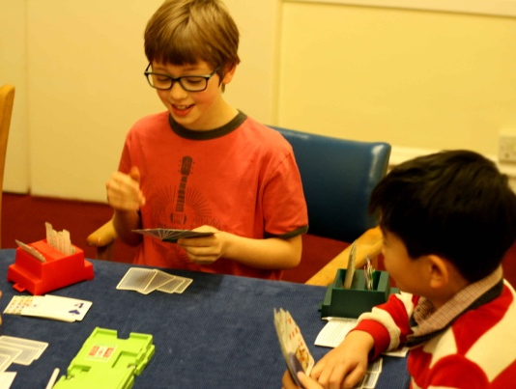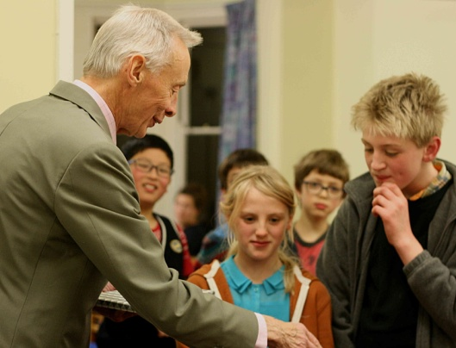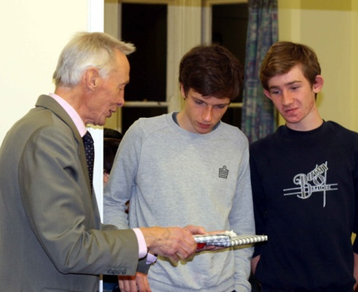
22nd November 2015
The average age of the Oxford Bridge Club attendee was lowered dramatically on the afternoon of Sunday 22nd November when thirty children, aged 8 – 18 years descended upon the balloon decorated premises generating laughter and good will.
With three sections to run, mini-bridge, novice bidders and experienced bidders, an accolade must surely go to our scorers and TDs, Diane Coe, Mike Fletcher and Peter Sherry, who managed to keep boards and children moving, in spite of the speed differentials of players and the cross table chatting!
At 4.15pm, we called a halt and everyone descended upon the tea table, groaning with goodies, mostly donated by parents, many of whom joined us for tea, while the scorers feverishly attempted to generate results.
The prizes were presented by Richard Sills, Chairman of the Oxford Bridge Club. In the mini-bridge section, first prize went to Reading siblings, Jacob and Alice Hathaway (in spite of one of them trumping the other’s ace!!!) In the novice bidders section, where we had four full tables, the results were extremely close with John Wood and Freya Baldwin taking first prizes and top prizes in the experienced section went to the Anstice brothers, Arthur and George.
However, so far as the volunteers were concerned, ALL the juniors were winners as we witnessed not a cross word, a sulk or a scowl all afternoon, only good cheer and a lovely atmosphere generated by all the competitors.
Warmest thanks to the Chairman and Trustees of the OBC for generously donating their premises, to David Bygott, our ‘official’ photographer and to all our volunteers present on the day, plus those who teach in the junior clubs and schools throughout the year.

