EBU Score for County Events
Normal Duplicate event
For Green Point events, see notes on web site under EBU Score
Event Details

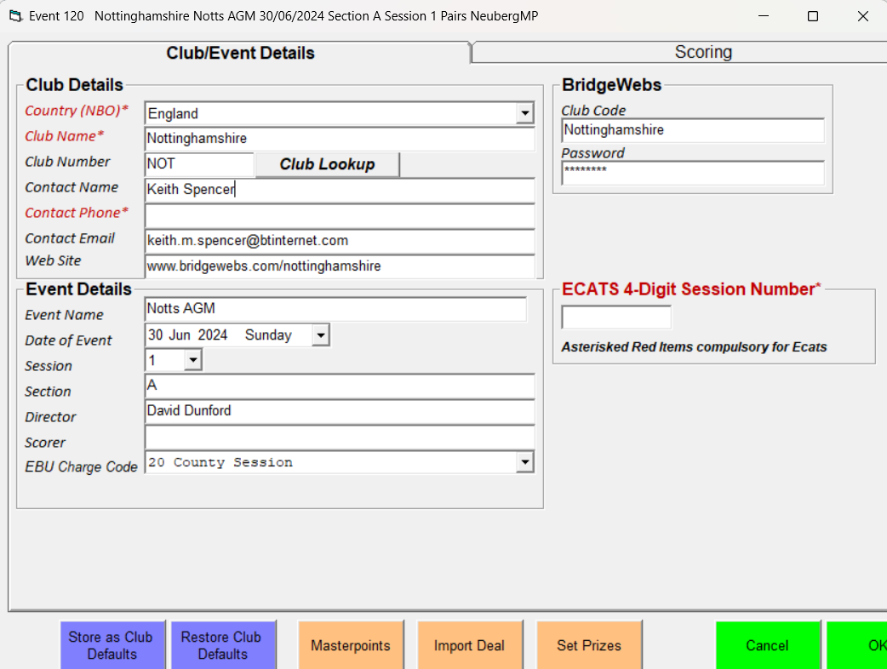

Club Details
Club Name: Nottinghamshire
Club Number: NOT
Event Details
EBU Charge Code: 20 County Session
Bridgewebs
Club Code: Nottinghamshire
Password:

Masterpoints
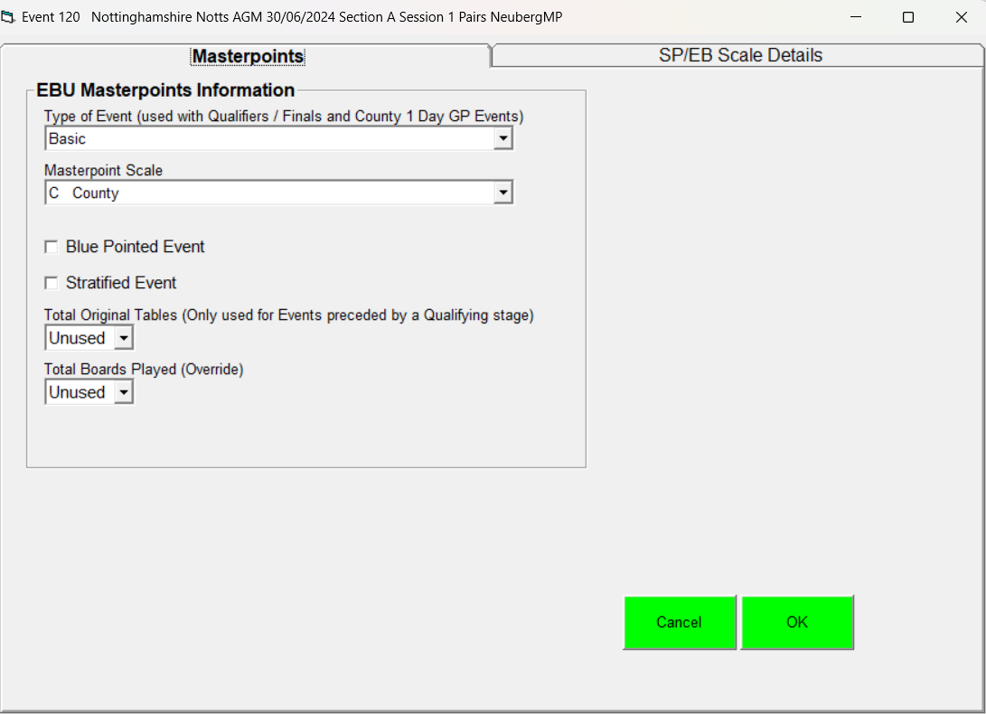
Masterpoint Scale: C County
For Green Point events, see notes on web site under EBU Score

