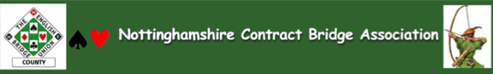
Notice of the Annual General Meeting to be held at
Nottingham Bridge Club on Sunday 30 June 2024 at 2.00 pm
AGENDA
- Welcome and Apologies for Absence

- Approval of the Minutes of Annual General Meeting Held on 20 May 2023 (enclosed)

- Matters Arising from the Minutes not Contained Within Other Agenda Items

- Chairman’s Report on Behalf of the Executive Committee

- Adoption of the Annual Accounts and Treasurer’s Report (enclosed)

- Appointment of an Independent Examiner for 2024/5 accounts

- Approval of EBU Fees for 25/265: No club affiliation fee and UMS fee of £0.04p

- Election of County Officers and Executive Committee Members (available after the closing date of 23 June 2024) (appendix 1)

- To Approve Minor Changes to the Constitution (appendix 2)

- Election of EBU Shareholders: Nominees Keith Spencer and Julia Staniforth

- Items Raised by Members for Resolution: Received from S Ashtari and supported by A Scott and I Dovey.
That NCBA money should not be used for anyone who’s primary allegiance is other than Nottinghamshire. To clarify, no entry fees to any competition should be paid by NCBA for anyone who’s primary allegiance is other than Nottinghamshire. Should they be selected to play in, for example in “Garden Cities” they would have to pay their own share of the team entry fee.
NCBA money should be for NCBA members only.

- Items Raised by Members for Future Consideration by the Executive Committee

- Date and Time of Next Meeting - To be determined by the Executive Committee

Julia Staniforth
NCBA Secretary

