Café Bridge
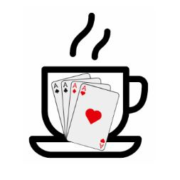
What is Café Bridge?
A Café Bridge event is a relaxed duplicate pairs game of bridge, just as you might play at your own Bridge Club. The difference is simply that instead of playing in your club venue, on this occasion the event is spread over multiple cafés and restaurants in the town centre of Bury St Edmunds. We are planning to use 8 separate cafés and restaurants, each agreeing to dedicate a number of their tables to the event. There will be friends and other bridge players wherever you go. You will play 6 rounds of 4 boards per round. The boards will stay in the venue, whilst you move between different cafés and restaurants, meeting up with new friends and other bridge players. We have allowed 15 minutes between each round to allow you to casually stroll through the town centre to your next venue.
You will receive your own movement card to guide you where to go next; and after the 3rd round is played you will have a light lunch in that café/restaurant. We are aiming to offer you the opportunity to select your preferred venue for lunch and also make your menu choice before the day.
The boards will be colour coded, so when you arrive at a new venue you will know where to sit for the next round. Scoring will be done by the North seated player using the BriAn Bridge App which is free to download and extremely easy to use. Help if needed will be available.
These fun events are extremely popular in parts of the country where they are organised, often attracting in excess of 100 pairs! Most importantly the event will support the local St Nicholas Hospice charity and aims to raise visibility and awareness of Bridge, by playing the game in the town centre. There will also be prizes for the first 3 pairs.
Any questions please contact derek.b@btinternet.com

