
Suffolk Bridge in association with Victor Lesk is holding an inaugural Café Bridge event in aid of the ‘St Nicholas Hospice Care’ charity on Thursday 19th September in Bury St Edmunds town centre. The event will run between 10.15 and 15.45 and will be held across the following venues.
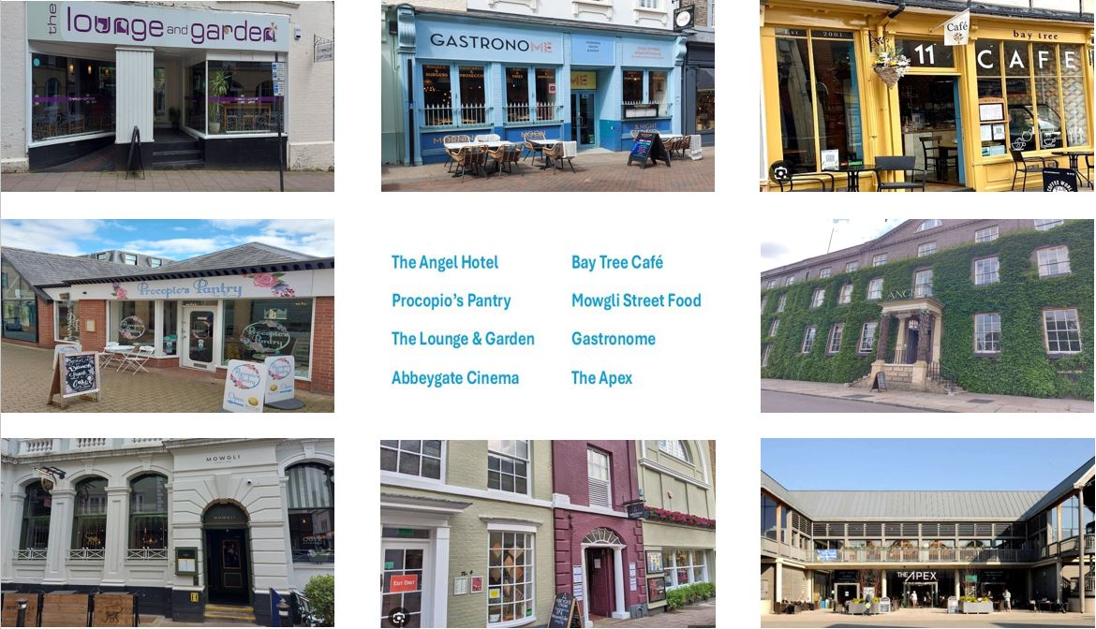
This promises to be a fun day playing relaxed Bridge in a social setting in Cafés and Restaurants in the town centre, moving between them after each round, with a light lunch included in the entrance fee of £30. St Nicholas Hospice Care will receive 50% of your entrance fee. Further details on the Suffolk, bridge website.

