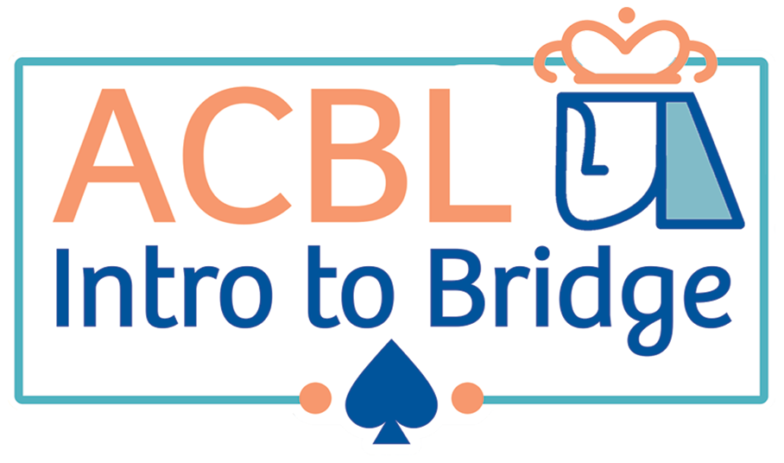

Announcing an introductory class to the game of bridge,

beginning in February 2025

The American Contract Bridge League (ACBL) and the Central Massachusetts Bridge Association (CMBA) are sponsoring a 10-week Intro to Bridge course in the Worcester area. Classes are on Thursdays from 4-6 PM beginning on Thursday February 20, 2025, running through April 24 and will take place at the Worcester Country Club, 2 Rice Street, Worcester. The course is tailored for new players and those looking for a refresh on the basics. Students will learn the mechanics of bridge, bidding and play, and they will play hands beginning in their very first class. Each class is designed with about 1/3 instruction and 2/3 interactive activities and play, reflecting ACBL’s “learn by doing” philosophy.

The course comes with a 120-day free guest membership to ACBL which gives students access to the online student workbook, class videos, answer keys, hand reviews (in the ACBL Resource Center) and more. The workbook lessons can be printed for each class or a hard copy version can be purchased online for about $10.

The course fee is $150, and you can sign up by sending your check and contact info (including email) to the instructor:

Michael Roman

13 Saddle Hill Dr.

Northborough, MA 01532

(please write “Intro to bridge” in the check’s memo line)

And if you have any questions, feel free to email them to Michael at mr@michaelromanphoto.com

NOTE: Worcester Country Club is a private club and not open to the public. However they are allowing the use of their clubhouse for the class. In recognition of this favor, CMBA is offering a ‘half off’ discount to WCC members, so their course fee is only $75.

There is also a follow-on Series 2 class that will be available in the spring, also 10 weeks, that delves deeper into bidding and play and includes much more supervised play.