**CASTLE BARGE**

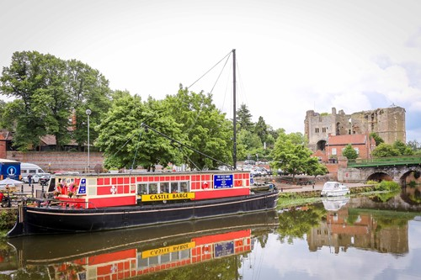

Newark Café Bridge

Tuesday 12th November 2024

**Choose 2 courses only i.e. Starter & Main, Main & Dessert or Starter & Dessert**

**MENU**

**Starters**

**Tomato and Basil Soup (V)**

served with Roll and Butter

**Vegetable Spring Roll**

with Salad

**Fish Cakes**

with Salad

**Mains**

**Breaded Wholetail Scampi,**

with Chips, Garden Peas & Tartare Sauce

**Steak & Ale Pie**

With Mixed Vegetables, Chips and Gravy

**Award Winning Lincolnshire Sausage**

with Mixed Vegetables, Mashed Potato & Gravy

**Vegetable Quiche (V)**

With Salad

**Desserts**

**Syrup Sponge (V)**

with Custard

**Chocolate Brownie (V)**

with Ice Cream

**LA VITA MIA**

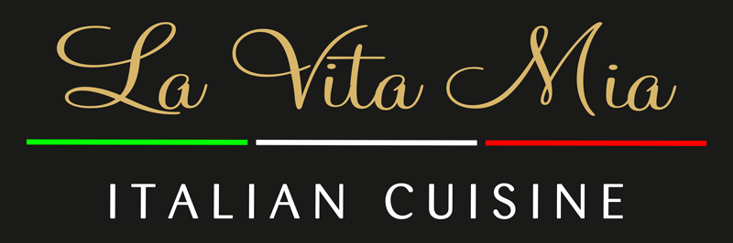

Newark Café Bridge

Tuesday 12th November 2024

**Choose 2 courses only i.e. Starter & Main, Main & Dessert or Starter & Dessert**

**MENU**

**Starters**

**Homemade Vegetable Soup (V, GF, Ve)**

served with Italian Bread

**Homemade Paté**

served with Toasted Italian Bread & Cranberry Sauce

**Prawn Cocktail (GF)**

with Salad

**Mains**

**Pizza Margherita (GF option)**

with Tomato, Cheese & Oregano

**Pollo Cream**

Pan-fried Chicken Breast with White Wine, Mushrooms & Cream Sauce,

served with potatoes & Vegetables

**Rissotto (V, Ve)**

Vegetarian Rissotto cooked in a Tomato Sauce

**Lasagne**

Layers of Pasta with Bechamel and Bolognese Sauce, baked with Mozzarella & Parmesan Cheese

**Desserts**

**Trio La Vita Mia**

a mix of Italian Gelato

**Brûlée Alla Vaniglia**

classic homemade Crème Brûlée

**Tiramisu**

served with a Chocolate Sauce

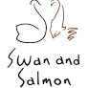

Newark Café Bridge

Tuesday 12th November 2024

**Choose 2 courses only i.e. Starter & Main, Main & Dessert or Starter & Dessert**

**MENU**

**Starters**

**Bruschetta (Ve, GF)**

Toasted Sour Dough with Chopped Tomatoes, Garlic, Red Onion, Basil, Oregano & Mixed Leaf

**Soup**

Carrot and Coriander Soup, Bread

**Polpette Meatballs (GF)**

Pork, Basil & Garlic Meatballs. Spicy Tomato Sauce, Grated Grana Padano

**Mains**

**Chicken Parmigiana**

Rosemary, Thyme & Garlic Breaded Chicken Breast, Chef’s Tomato Sauce, Mozzarella,

Served with either Spaghetti or Fries and Salad

**Sausage & Mash**

Owen Taylor’s ‘Award-Winning’ Sausages, Creamed Mash, Garden Peas,

Battered Onion Rings and Onion Gravy

**Keralan Curry (V)**

Cauliflower, Red Pepper, Onion, Tomato and Coconut served with Rice.

**Desserts**

**Sicilian Lemon Tart**

with Raspberry Coulis, Raspberry Sorbet

**Crème Brûlée**

Shortbread Biscuit

**Caramel Chocolate Brownie (Ve)**

With Vanilla Ice Cream

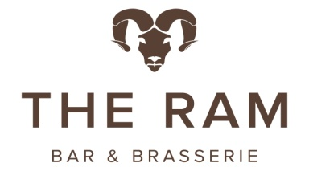

Newark Café Bridge

Tuesday 12th November 2024

**Choose 2 courses only i.e. Starter & Main, Main & Dessert or Starter & Dessert**

**MENU**

**Starters**

**Loaded Halloumi Fries (V)**

*With Roasted Red Pepper and Spring Onion*

**Wild Mushroom Soup (V)**

*With Bread Roll*

**Lamb Samosas**

*With Raita*

**Mains**

**Cod and Chips**

*Homemade Chunky Chips, Mushy Peas and Tartare Sauce*

**Caesar Salad with Chicken and Bacon**

*Traditional Caesar Salad with Our Homemade Caesar Dressing*

**Halloumi Burger (V)**

*With Mixed Leaves, Tomato, Red Onion, Roasted Red Pepper and Hummus.*

*Homemade Chunky Chips and Slaw*

**Desserts**

**Chocolate Sponge (V)**

*Vanilla Ice-Cream*

**Eton Mess Sundae (V)**

Newark Café Bridge

Tuesday 12th November 2024

**Choose 2 courses only i.e. Starter & Main, Main & Dessert or Starter & Dessert**

**MENU**

**Starters**

**Soup of the Day (V)**

with fresh Welbeck Olive or Baguette Bread or a gluten free Muffin

…Please specify as order

**Smoked Mackerel Pate**

with Toast

**Mains**

**Coq au Vin**

with Mash

**Beef Lasagne**

with Salad or Garlic Bread …Please specify as order

**Mushroom & Hazelnut Lasagne (V)**

with Salad or Garlic Bread …Please specify as order

**Vegetarian Quiche (V)**

with Salad

**Desserts**

**Sticky Toffee Pudding (V)**

with Ice Cream

**Crumble of the Day (V)**

with Custard

**Tart of the day (V)**

with Cream