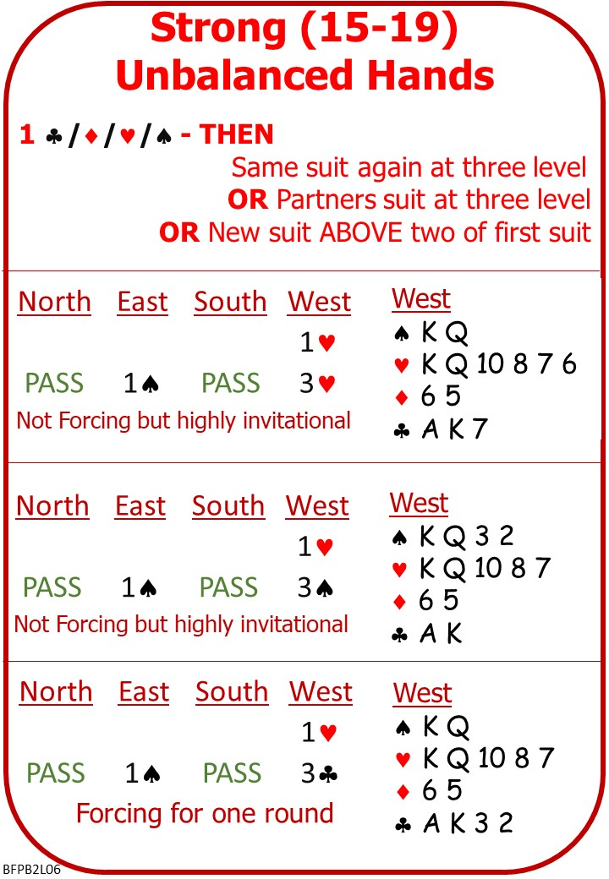
A few bridge hands have 15-19 HCPs and are unbalanced.

You cannot open No Trumps with these hands.

It will take two bids to show your partner what you have.

Please find attached:
- Lesson 5 Weak Unbalanced Hands Quiz with Answers
- Lesson 6 Stronger Unbalanced Hands Notes
- Lesson 6 Stronger Unbalanced Hands Homework

On No Fear Bridge: Menu across the top:
1 Practice Hands and Quizzes
Millionaire Quiz: Openers Rebid

2 Practice Hands and Quizzes
Bidding Practice: Openers Rebid

Invite to Next Lesson

