**In our last lesson**

When your partner opens the bidding with a bid of 1NT, we know a lot about their hand. If we have a balanced hand, our task is to decide whether a game bonus is available.

If we have an unbalanced hand, the partnership needs to play in a trump contract.

The question is: do we have less than 25HCPs between us, and therefore must play in a low contract, OR do we have a fit in a major, 25+HCPs, and should go for ten tricks and collect a game bonus?

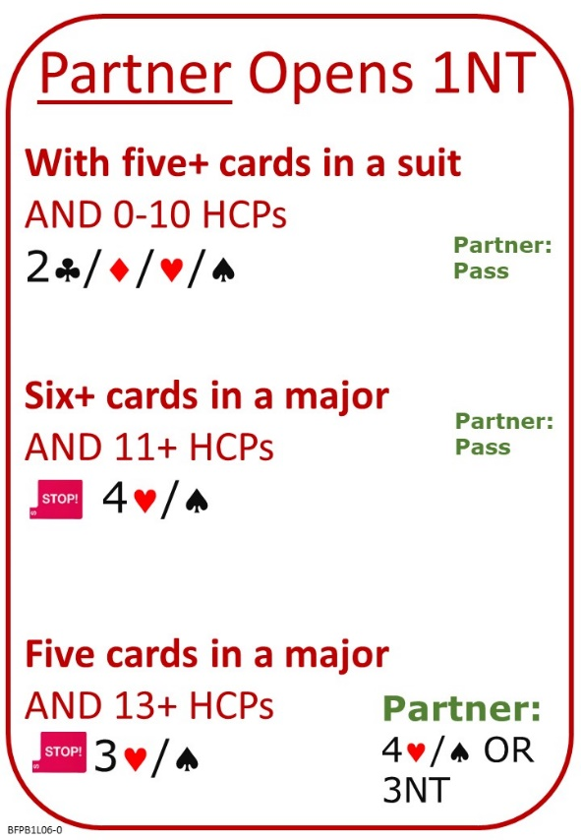

**Please find attached:**

Lesson 5 Reply to 1 No Trump with Balanced Hand: Quiz with Answers

Lesson 6 Reply to 1 No Trump with Unbalanced Hand: Notes  
Lesson 6 Reply to 1 No Trump with Unbalanced Hand: Quiz

**No Fear Bridge:**

Click on the centre button: “Practice Hands and Quizzes” at the top of the Home Page…

Click “Bidding Quizzes”

Click [Responding to 1NT with unbalanced hands](https://www.nofearbridge.co.uk/members/go.php?A=bidquestions&P=2&T=B010&L=1&S=1&C=T)

Click on the left button: “Guided Learning” at the top of the Home Page…

Under “Courses”

Level 1 – Beginners “Bridge in 30 Lessons (Part 1 of 3)”

Lesson 6

Presentation/Tutorial: [Simple](https://www.nofearbridge.co.uk/acol/HD12_3rd_Hand_High.pdf) Finesse

Hands to Play: Finessing Level 1

Quiz: Leads Training Beginners Easy