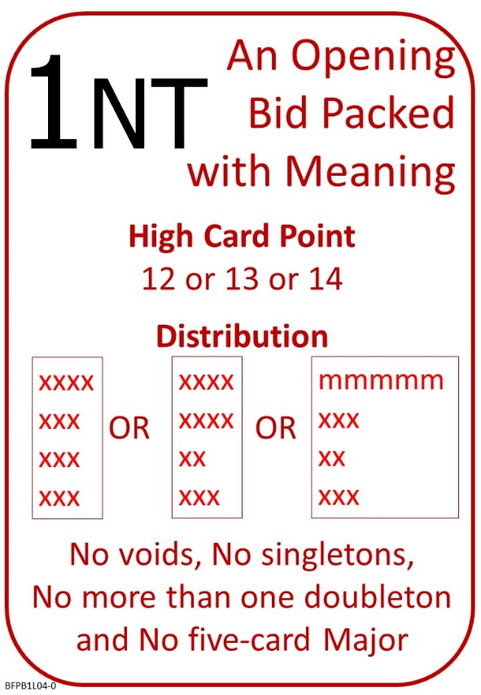
In our last lesson
We agree with our partner, that when we open the bidding with a bid of 1NT, we are describing our hand quite precisely.

Please find attached:
Lesson 3 Introduction to the Auction: Quiz with Answers
Lesson 4 Opening 1 No Trumps
Notes
Quiz

On No Fear Bridge:
From Home Page Home Page Click “Guided Learning”, then “Courses”:
Bridge in 30 Lessons (Part 1 of 3)
Lesson 4 – Introduction to the Bidding and Opening 1NT
Tutorials: Introduction to the bidding; Aims of the bidding; and Introduction to 1NT Opening Bid
Quiz: Responding to 1NT with Balanced Hands
Document: Which card to lead against No Trumps

And/or
From Home Page Home Page Click “Practice Activities”, then “Declarer Hands”:
Level 1 - Beginners
From the list: All No Trumps Contracts

